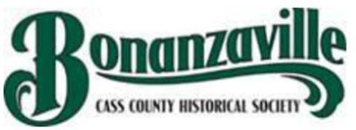

Cass County, ND, Historical Society, Inc.
Agenda
10/20/2021, 5:30 pm

Notice is hereby given that a meeting of the Cass County, ND, Historical Society Board of Directors, a North Dakota Corporation, is hereby called and will be held in the Event Center at Bonanzaville, West Fargo, ND to conduct such business as may properly come before the board, including the following:

Call to Order Roll Call
Agenda Approval /additions:
Minutes: 9/15/2021
Presidents Report: John Lund

Finance Committee Report: Brad Stedman
Committee Reports (Collection Buildings, Grounds, Safety, Volunteer)
Executive Director: Beth Jansen Report discussion as needed.

Old Business:

Keller Exhibit update

New Business:

Adjourn

Finance Committee meets at 4:30 p.m. Next Meeting: 11/17/2021

